Step 1: Download helm

curl -fsSL -o get_helm.sh https://raw.githubusercontent.com/helm/helm/main/scripts/get-helm-3

$ chmod 700 get_helm.sh

$ ./get_helm.sh

Step 2: create a nginx ingress namespace to run nginx ingress controller

kubectl apply -f https://raw.githubusercontent.com/kubernetes/ingress-nginx/nginx-0.29.0/deploy/static/mandatory.yaml

kubectl get namespace

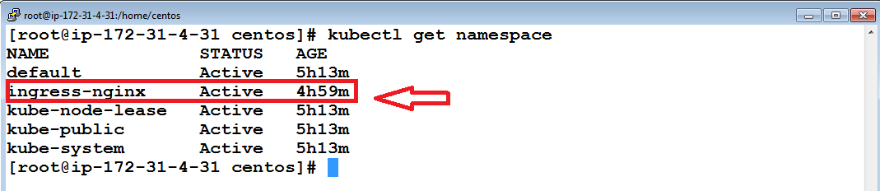

step 3: with the below command run a pod for ingress controller and as well service for ingress controller exposed on the nodeport

kubectl apply -f https://raw.githubusercontent.com/kubernetes/ingress-nginx/nginx-0.29.0/deploy/static/provider/baremetal/service-nodeport.yaml

kubectl get pods -n ingress-nginx

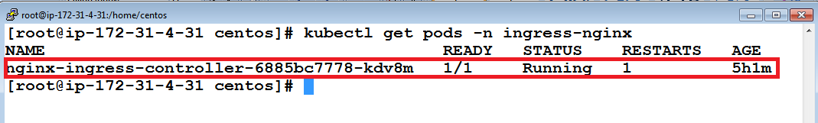

Step 4 :create a helm chart in your name

helm create ajay

cd ajay

ls

cd templates

ls

step 5: delete the default things in the deployment.yaml and create the below resource

vim deployment.yaml

apiVersion: apps/v1

kind: Deployment

metadata:

name: nginx

spec:

replicas: 3

selector:

matchLabels:

app: nginx

template:

metadata:

labels:

app: nginx

spec:

containers:

- name: nginx

image: nginx:1.13

ports:

-containerPort: 80

step 6: delete the default things in the service.yaml and create the below resource

Vim service.yaml

apiVersion: v1

kind: Service

metadata:

name: nginx

spec:

selector:

app: nginx

ports:

- name: main

protocol: TCP

port: 80

targetPort: 80

step 7: delete the default things in the ingress.yaml and create the below resource

vim ingress.yaml

apiVersion: extensions/v1beta1

kind: Ingress

metadata:

name: nginx

annotations:

http.port: "443"

spec:

backend:

serviceName: nginx

servicePort: 80

Step 8: create clusterrolebinding for kubelet to accept requests from helm to deploy objects in the cluster

kubectl create clusterrolebinding permissive-binding --clusterrole=cluster-admin --user=admin --user=kubelet --group=system:serviceaccounts

Step 9 : run the following commands to verify your deployment

kubectl get deploy

kubectl get rs

kubectl get pods

helm install mychart ajay

Step 10: get the port exposed on the node level by ingress pod

kubectl get svc -n ingress-nginx

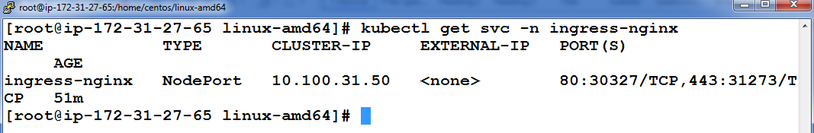

Step 11: Hit with any slave node ip with the port that is exposed for your ingress pod

<http://3.112.199.34:30327/>

